#Heterogeneous Migration From MySQL to PostgreSQL Using AWS Schema Conversion Tool.
==================================================================================================================================

Migrate Data From MySQL Database To Postgres Database Using ----> AWS Schema Conversion Tool.
=======================================================================================================================================

step 1: install AWS Schema Conversion Tool.
link----> https://docs.aws.amazon.com/SchemaConversionTool/latest/userguide/CHAP_Installing.Procedure.html

---> install [mysql-connector-j-26.7.0] .jar file link----> https://dev.mysql.com/downloads/connector/j/

---> install [PostgreSQL-42.7.13] .jar file link----> https://jdbc.PostgreSQL.org/download/

step 2: open AWS Schema Conversion Tool ---> Go to Setting ----> click Global Setting -----> and Left Side click to Driver ---->
Add MySQL and postgress Driver Download Path From Browser ---> click APPLY and OK.

step 3: Open AWS Console
i) Create first MySQL RDS which is our Source-database. -----> Allow Public Access.
ii) Create Second POstgress RDS which is our Target-database. -----> Allow Public Access.

Step 4: i) Connect to the MySQL Database and create one database and user

CREATE DATABASE source_ecommerce;
CREATE USER 'sct_user'@'%' IDENTIFIED BY 'Password@123';
GRANT ALL PRIVILEGES ON source_ecommerce.* TO 'sct_user'@'%';
FLUSH PRIVILEGES;

Create sample Tables:
CREATE TABLE departments (
department_id INT AUTO_INCREMENT PRIMARY KEY,
department_name VARCHAR(50) NOT NULL UNIQUE,
location VARCHAR(50) DEFAULT 'Main Campus'
);

INSERT INTO departments (department_name, location) VALUES
('Engineering', 'Building A'),
('Data Science', 'Building A'),
('Human Resources', 'Building B'),
('Marketing', 'Remote'),
('Finance', 'Building B');

ii)Connect to the Postgress Database and create one database and user

CREATE DATABASE target_ecommerce;
CREATE USER sct_user WITH PASSWORD 'Password@123';
GRANT ALL PRIVILEGES ON DATABASE target_ecommerce TO sct_user;

Step 5: open AWS Schema Conversion Tool ---> Click on File ----> click New Project ----> Enter Project Name ----> Local Store Path.

Step 6: Top of AWS Schema Conversion Tool Click Add Source ---> Select MySQl

Connection Name: MySQL_RDS

Server name: Source database MySQL Endpoint From RDS.

Port: 3306

User name: admin

Password: RDS Master Password

Click on Store Password

Click Test Connection ---> Connection Success Popup and Click Connect Done.

Step 7: Top of AWS Schema Conversion Tool Click Add Target ---> Select Amazon RDS for postgressql

Connection Name: Postgressql_RDS

Server name: Target database Postgres Endpoint From RDS.

Port: 5432

User name: Postgres

Password: RDS Master Password

Click on Store Password

Click Test Connection ---> Connection Success Popup and Click Connect Done.

Step 8: i) Left Side Click Server Arrow ---> Click Schema Arrow ---> Click Our Database eg.Source_ecommerce Click That Check Box ---
-->Click Create mapping Button see in the Center of Screen .

Right Click on our database Source_ecommerce and click on Create Report (Then we can see all our table,schemas in our database).

Right Click on our database Source_ecommerce and click on Convert Schema.
ii) Right Side Target Database Click on Postgres Arrow ---> Click Schema Arrow ---> Click on our Database eg.Source_ecommerce ----
--> Right Click on Source_ecommerce and Click on Apply To Database.
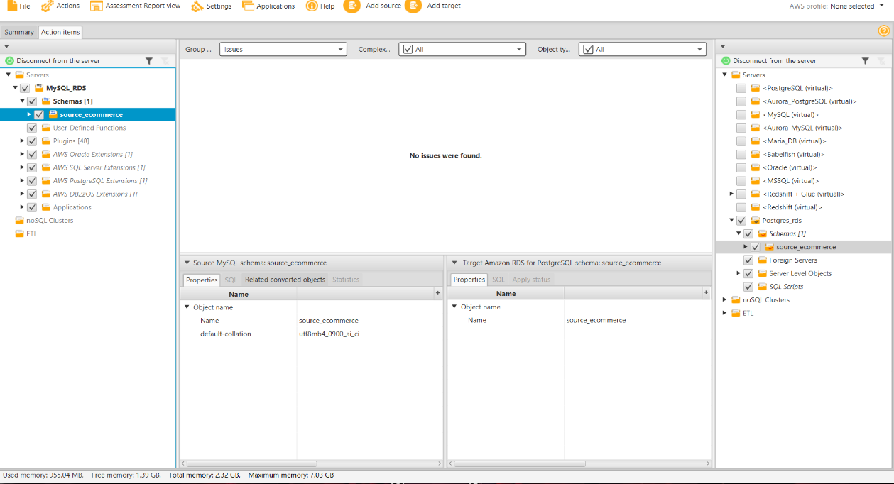

Step 9: Open DMS Service from AWS ---> Create Replication instances ---> Create Endpoint For Both Source-database and Target-database--
----> Create Task -----> after creation Start Task
- Go to PostgreSQL and Run This Command SELECT * FROM source_ecommerce.Departments;

This is My MySQL Database Screenshot: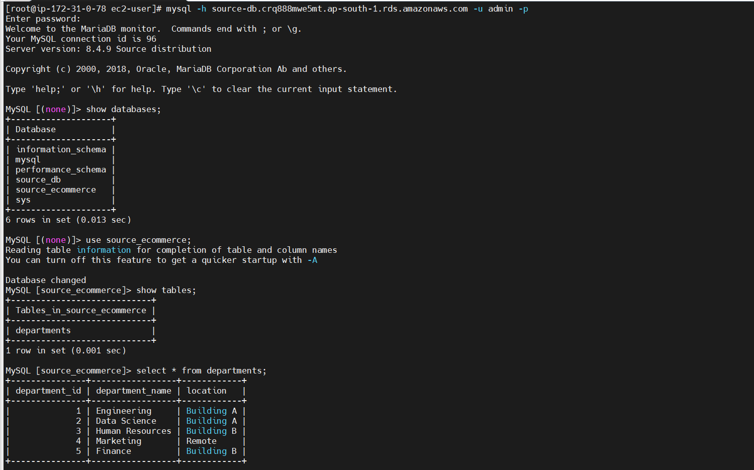

This is My PostgreSQL Database Screenshot:

